**Project report template**

1. **Introduction**
   1. **Overview**

Title : ***A comprehensive analysis of financial performance insights from leading banks***

The global forces for change include technological innovation; the deregulation of financial services at the national level and opening-up to international competition; and - equally important - changes in corporate behavior, such as growing disintermediation and increased emphasis on shareholder value.

* 1. **Purpose**

We are trying to analyse the bank related data and able to extract some insights from the using business intelligence tools.

1. **Problem definition and Design thinking**
   1. **Empathy map**

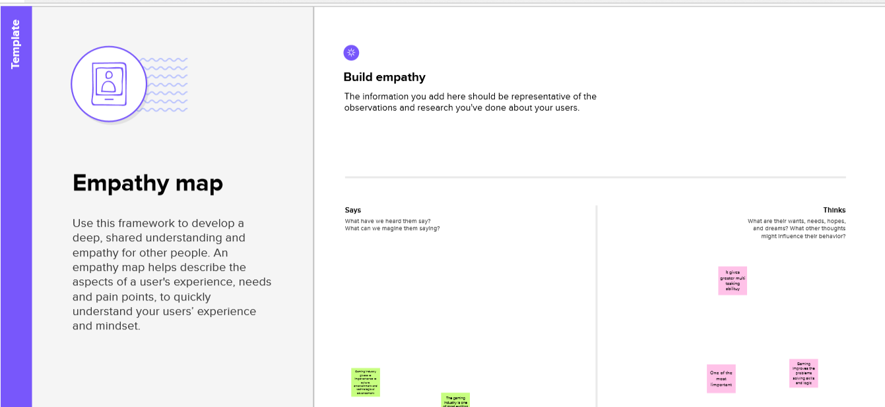

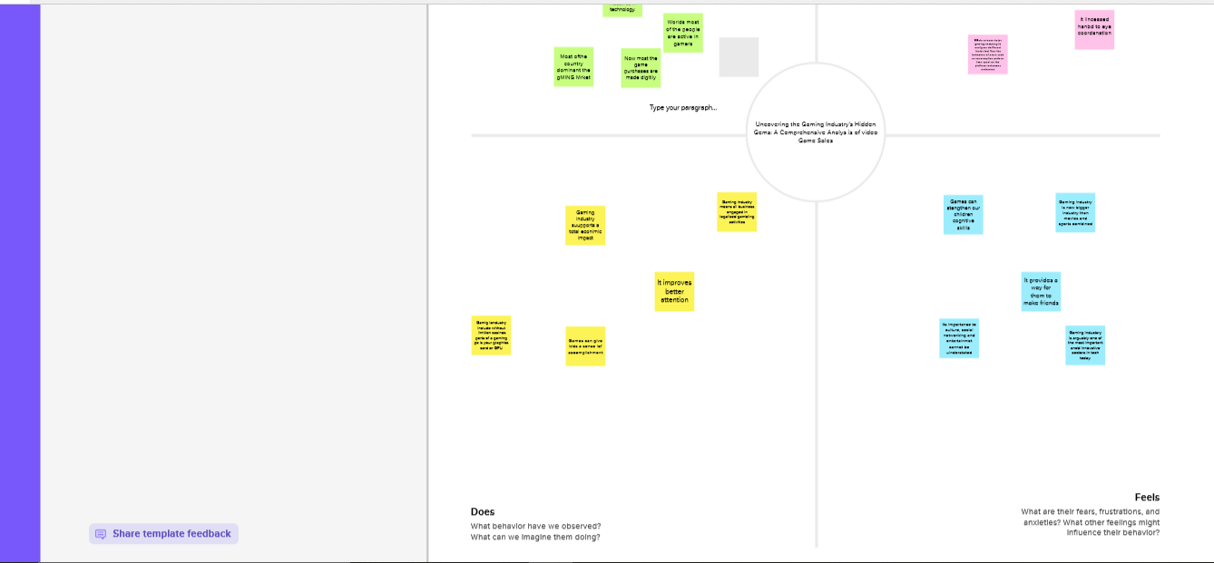

* 1. **Brainstorming map**

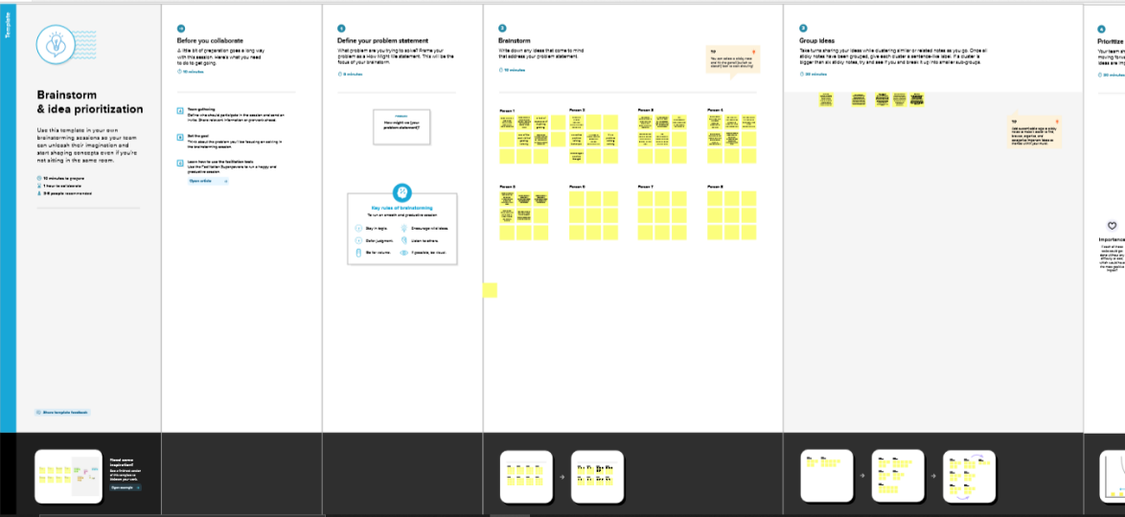

1. **Result**

**Findings**:

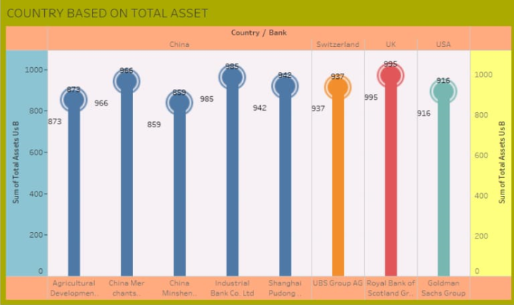

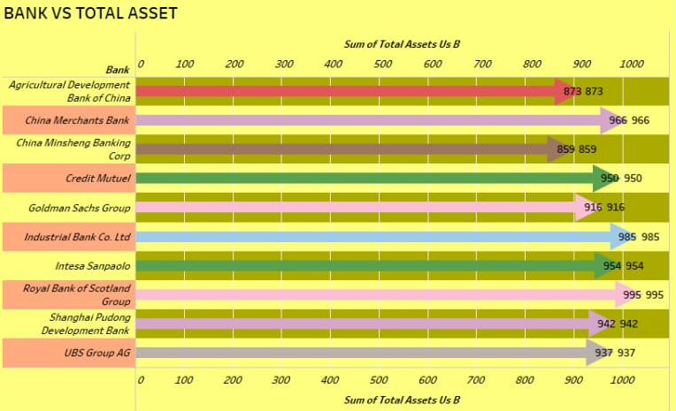

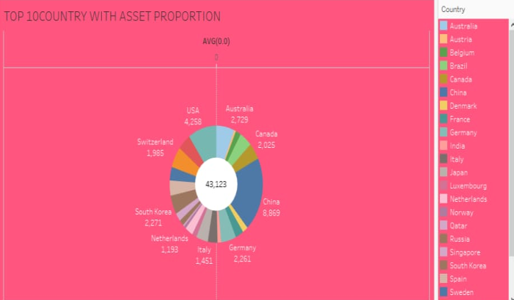

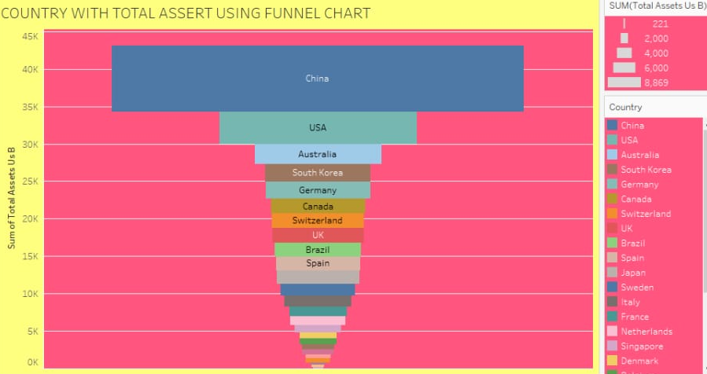

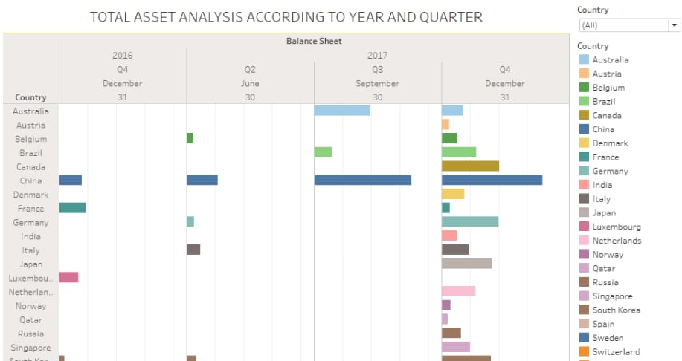

1. **Advantages**

The Ability to Detect Patterns. Financial statements reveal how much a company earns per year in sales

A Chance to Budget Outline

**Disadvantages**

Based on Market Patterns.

At-One-Time Analysis

1. **Applications**

It provides financial information such as the company’s asset structure, asset liquidity, source of the funds, debit level and liability structure.

Making financial statements is useful for avoiding financial risks.

1. **Conclusion**

Analysis of financial statements is extremely important for every business to grow and increase their revenue. It should not be compromised since it increases the efficiency of business operations It provides various financial information.

1. **Future scope**

It will show a position of a period of time as in the case of a balance sheet or may reveal a series of activities over a given period of time.

1. **Appendix**

Source code

